Metric Conversion
# Source: AI Source: Provided by: [Data Path: Persons Table -> ID Column: 1, Name_En Column: Motasem Essam] -> From: [ChatGPT] on [7/17/2026]
Metric Conversion is the process of changing a measurement from one metric unit to another while preserving the same quantity. The metric system is based on powers of 10, making conversions straightforward by multiplying or dividing by 10, 100, 1000, and so on.
Metric conversion is widely used in science, engineering, medicine, manufacturing, education, and everyday life.

Definition
# Source: AI Source: Provided by: [Data Path: Persons Table -> ID Column: 1, Name_En Column: Motasem Essam] -> From: [ChatGPT] on [7/17/2026]
Metric Conversion is the process of converting a measurement from one metric unit to another equivalent metric unit without changing the actual quantity being measured.

Purpose
# Source: AI Source: Provided by: [Data Path: Persons Table -> ID Column: 1, Name_En Column: Motasem Essam] -> From: [ChatGPT] on [7/17/2026]
Metric conversion is used to:
- Express measurements in appropriate units.
- Compare measurements using the same unit.
- Simplify calculations.
- Support scientific and engineering work.
- Standardize measurements internationally.

Characteristics
# Source: AI Source: Provided by: [Data Path: Persons Table -> ID Column: 1, Name_En Column: Motasem Essam] -> From: [ChatGPT] on [7/17/2026]
Metric conversion:
- Uses the metric (SI) system.
- Is based on powers of 10.
- Does not change the physical quantity.
- Only changes the unit in which the quantity is expressed.

Metric Prefixes
# Source: AI Source: Provided by: [Data Path: Persons Table -> ID Column: 1, Name_En Column: Motasem Essam] -> From: [ChatGPT] on [7/17/2026]
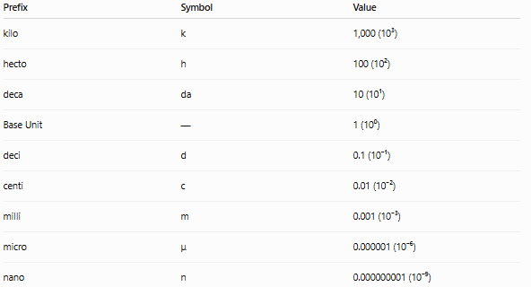
Prefix | Symbol | Value
kilo | k | 1,000 (10³)
hecto | h | 100 (10²)
deca | da | 10 (10¹)
Base Unit | — | 1 (10⁰)
deci | d | 0.1 (10⁻¹)
centi | c | 0.01 (10⁻²)
milli | m | 0.001 (10⁻³)
micro | μ | 0.000001 (10⁻⁶)
nano | n | 0.000000001 (10⁻⁹)

Common Metric Units

Length
# Source: AI Source: Provided by: [Data Path: Persons Table -> ID Column: 1, Name_En Column: Motasem Essam] -> From: [ChatGPT] on [7/17/2026]
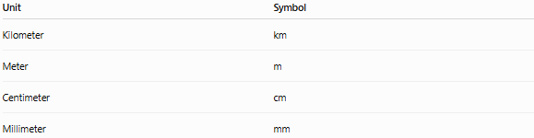
Unit | Symbol
Kilometer | km
Meter | m
Centimeter | cm
Millimeter | mm

Mass
# Source: AI Source: Provided by: [Data Path: Persons Table -> ID Column: 1, Name_En Column: Motasem Essam] -> From: [ChatGPT] on [7/17/2026]
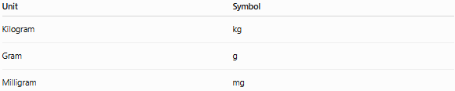
Unit | Symbol
Kilogram | kg
Gram | g
Milligram | mg

Capacity
# Source: AI Source: Provided by: [Data Path: Persons Table -> ID Column: 1, Name_En Column: Motasem Essam] -> From: [ChatGPT] on [7/17/2026]

Unit | Symbol
Kiloliter | kL
Liter | L
Milliliter | mL

Basic Conversion Rule
# Source: AI Source: Provided by: [Data Path: Persons Table -> ID Column: 1, Name_En Column: Motasem Essam] -> From: [ChatGPT] on [7/17/2026]
- Larger unit → Smaller unit: Multiply.
- Smaller unit → Larger unit: Divide.

Length Conversions
# Source: AI Source: Provided by: [Data Path: Persons Table -> ID Column: 1, Name_En Column: Motasem Essam] -> From: [ChatGPT] on [7/17/2026]
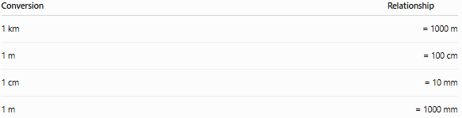
Conversion | Relationship
1 km | = 1000 m
1 m | = 100 cm
1 cm | = 10 mm
1 m | = 1000 mm
Examples
- 3 km = 3000 m
- 2.5 m = 250 cm
- 450 cm = 4.5 m
- 75 mm = 7.5 cm

Mass Conversions
# Source: AI Source: Provided by: [Data Path: Persons Table -> ID Column: 1, Name_En Column: Motasem Essam] -> From: [ChatGPT] on [7/17/2026]
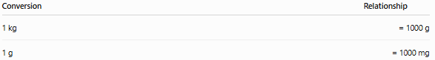
Conversion | Relationship
1 kg | = 1000 g
1 g | = 1000 mg
Examples
- 5 kg = 5000 g
- 3500 g = 3.5 kg
- 2 g = 2000 mg
- 750 mg = 0.75 g

Capacity Conversions
# Source: AI Source: Provided by: [Data Path: Persons Table -> ID Column: 1, Name_En Column: Motasem Essam] -> From: [ChatGPT] on [7/17/2026]
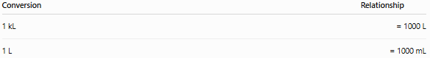
Conversion | Relationship
1 kL | = 1000 L
1 L | = 1000 mL
Examples
- 4 L = 4000 mL
- 2500 mL = 2.5 L
- 3 kL = 3000 L

Area Conversions
# Source: AI Source: Provided by: [Data Path: Persons Table -> ID Column: 1, Name_En Column: Motasem Essam] -> From: [ChatGPT] on [7/17/2026]
Because area is two-dimensional, the conversion factor is squared.
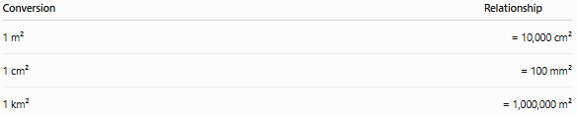
Conversion | Relationship
1 m² | = 10,000 cm²
1 cm² | = 100 mm²
1 km² | = 1,000,000 m²
Examples
- 2 m² = 20,000 cm²
- 500 cm² = 0.05 m²

Volume Conversions
# Source: AI Source: Provided by: [Data Path: Persons Table -> ID Column: 1, Name_En Column: Motasem Essam] -> From: [ChatGPT] on [7/17/2026]
Because volume is three-dimensional, the conversion factor is cubed.
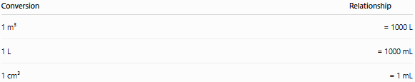
Conversion | Relationship
1 m³ | = 1000 L
1 L | = 1000 mL
1 cm³ | = 1 mL
Examples
- 2 m³ = 2000 L
- 750 mL = 0.75 L
- 25 cm³ = 25 mL

Conversion Ladder
# Source: AI Source: Provided by: [Data Path: Persons Table -> ID Column: 1, Name_En Column: Motasem Essam] -> From: [ChatGPT] on [7/17/2026]
kilo → hecto → deca → Base → deci → centi → milli
- Moving right → Multiply by 10 for each step.
- Moving left → Divide by 10 for each step.
Example:
m → cm
Move two steps right:
Multiply by 100
5 m = 500 cm

Applications
# Source: AI Source: Provided by: [Data Path: Persons Table -> ID Column: 1, Name_En Column: Motasem Essam] -> From: [ChatGPT] on [7/17/2026]
Metric conversion is used in:
- Science
- Engineering
- Manufacturing
- Medicine
- Construction
- Surveying
- Education
- Laboratory work
- Everyday measurements

Advantages
# Source: AI Source: Provided by: [Data Path: Persons Table -> ID Column: 1, Name_En Column: Motasem Essam] -> From: [ChatGPT] on [7/17/2026]
Metric conversion:
- Is simple because it uses powers of 10.
- Reduces calculation errors.
- Is internationally standardized.
- Supports accurate communication.
- Makes scientific calculations easier.

Common Mistakes
# Source: AI Source: Provided by: [Data Path: Persons Table -> ID Column: 1, Name_En Column: Motasem Essam] -> From: [ChatGPT] on [7/17/2026]
- Multiplying when division is required.
- Forgetting that area uses squared conversion factors.
- Forgetting that volume uses cubed conversion factors.
- Mixing metric and non-metric units.
- Misplacing the decimal point.

Key Points
# Source: AI Source: Provided by: [Data Path: Persons Table -> ID Column: 1, Name_En Column: Motasem Essam] -> From: [ChatGPT] on [7/17/2026]
- Metric Conversion changes the unit, not the quantity.
- The metric system is based on powers of 10.
- Larger → Smaller units: Multiply.
- Smaller → Larger units: Divide.
- Area conversions use squared factors.
- Volume conversions use cubed factors.
- Metric conversion is fundamental in science, engineering, and everyday life.

Conclusion
# Source: AI Source: Provided by: [Data Path: Persons Table -> ID Column: 1, Name_En Column: Motasem Essam] -> From: [ChatGPT] on [7/17/2026]
Metric Conversion is the process of expressing the same physical quantity in different metric units by multiplying or dividing according to powers of 10. Because the metric system is decimal-based, conversions between units such as kilometers and meters, kilograms and grams, or liters and milliliters are simple and consistent. Special care is required for area and volume, where the conversion factors must be squared or cubed. Mastering metric conversion is essential for accurate calculations, scientific communication, engineering design, manufacturing, and everyday measurement tasks.

